Code Example 1: Linear MPC
Code: week_8_example_1.py
Code description: Implementation of linear MPC problem using CVXPY
https://www.cvxpy.org/
Objective is to stabilize a linear dynamical system described by a state space model
https://colab.research.google.com/github/cvxgrp/cvx_short_course/blob/master/book/docs/intro/notebooks/control.ipynb
Problem description:
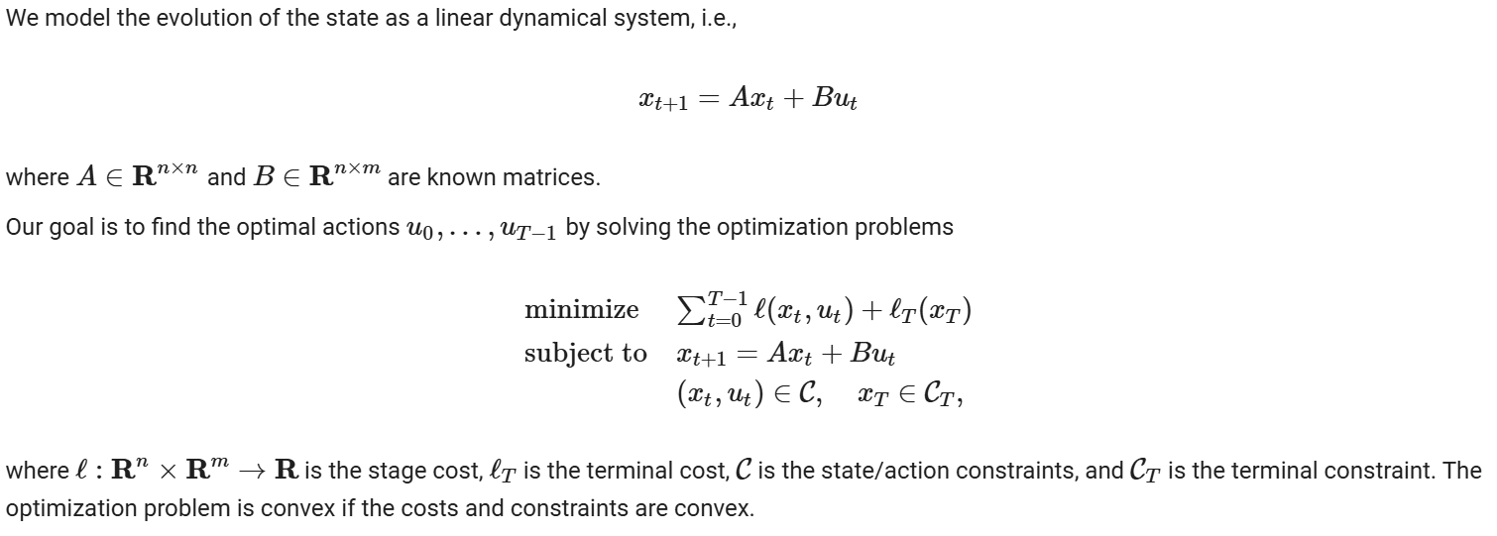

Code Example 2: Linear MPC
Code: week_8_example_2.py
Code description: Implementation of linear MPC problem using CVXPY and OSQP solver
https://osqp.org/docs/examples/mpc.html
Optional: investigate the code implementation in python using scipy library
Problem description: Objective is to stabilize a linearized quadcopter model
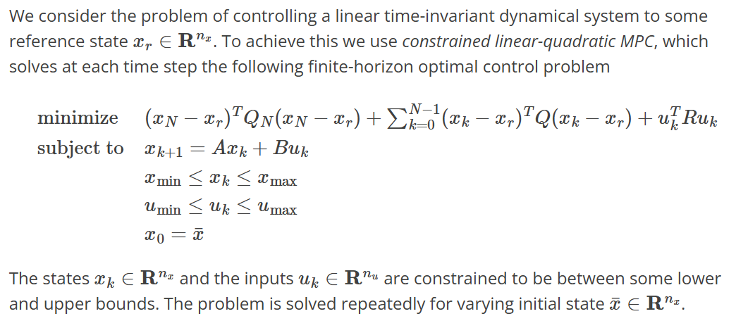

Code Example 3: Nonlinear MPC
Code: week_8_example_3.py
Code description: Implementation of nonlinear MPC problem using CasADi
https://web.casadi.org
Problem description:
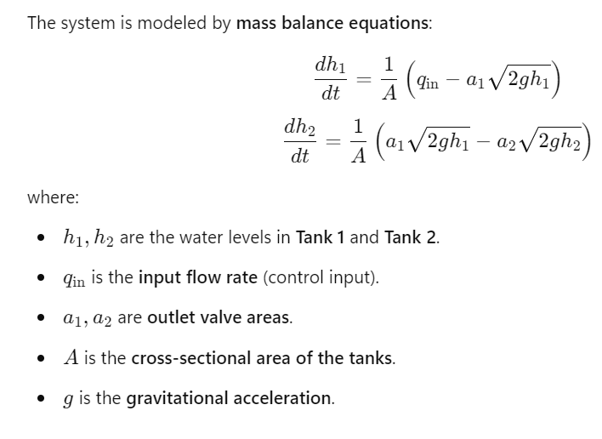
MPC cost function and constraints
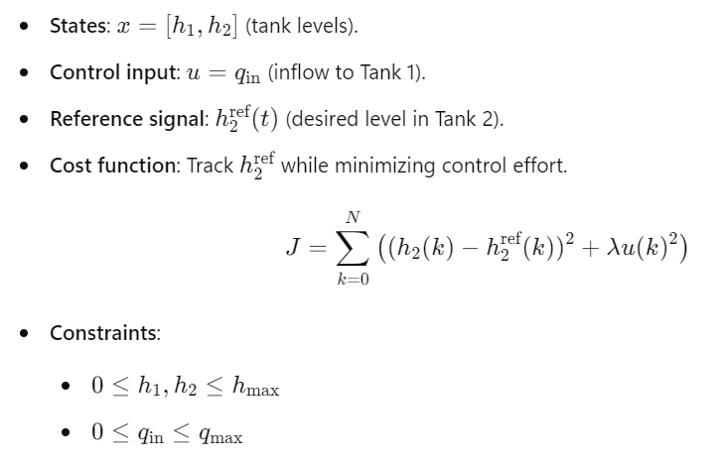

Code Example 4: Nonlinear MPC
Code: week_8_example_4.py
Code description: Implementation of nonlinear MPC problem using CasADi
https://web.casadi.org
Problem description: Stabilization of inverted pendulum
The inverted pendulum dynamics describe the motion of a pendulum that is balanced on a pivot, typically stabilized using a control system. It is a classic problem in control theory and reinforcement learning.
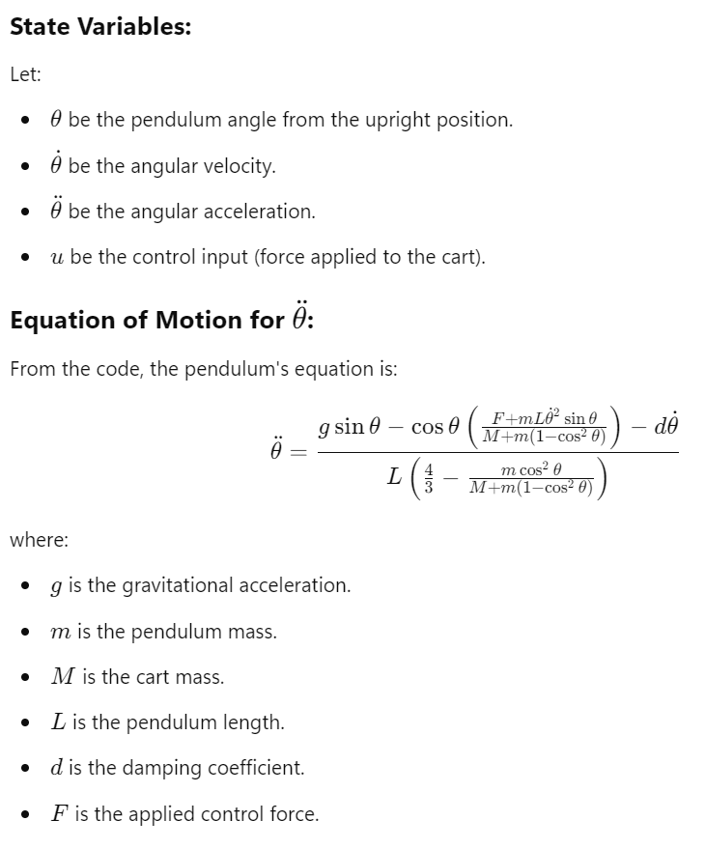


Code Example 5: Deep Reinforcement Learning
Code: week_8_example_5.py
Code description: Implementation of RL algorithm using Stable-Baselines3
https://stable-baselines3.readthedocs.io/en/master/
using environment from Gymnasium
https://pypi.org/project/gymnasium/
Problem description: Objective is to stabilize the cart pole environment (inverted pendulum)
https://colab.research.google.com/github/Stable-Baselines-Team/rl-colab-notebooks/blob/sb3/multiprocessing_rl.ipynb

